Final Report

Introduction
The real estate market is influenced by various factors such as house age, renovation status, number of bedrooms and bathrooms, and overall size. This project aims to analyze housing market trends and visualize key insights using Tableau to better understand how different features impact sale prices.

Project overviews
The dataset contains Transformed housing data and 21,609 house sale records, including Property features such as Sales price, area, bedrooms, bathrooms, floors and location. There are a total of 31 columns, out of which Sale Price can be supposedly taken as a dependent variable. The other variables are different features, locations and date, etc. regarding the houses. This project, "Visualizing Housing Market Trends: An Analysis of Sale Prices and
Features using Tableau," aims to explore and analyze housing market trends using the Transformed Housing Data 2 dataset from Kaggle. The objective is to identify key factors influencing house prices, such as location, size, number of bedrooms, bathrooms, floors and basement area.
By leveraging Tableau, the project will create interactive dashboards, story, bar chart, histogram, summary dashboard to visualize patterns, compare regional price variations, and gain insights into how different features impact house sale prices. The analysis will help in making data- driven decisions for buyers, sellers, and real estate professionals.

  - Objectives
    - Identify key factors influencing house prices.
    - Analyze the effect of renovations on property value.
    - Explore the distribution of house sales across different price ranges.
    - Create interactive Tableau dashboards to present findings effectively.

Project Initialization and Planning Phase

  - Define Problem Statement

Problem  Statement (PS) | I am (Customer) | I’m trying to | But | Because | Which makes me feel
PS-1 | A first-time homebuyer who wants to make an informed decision | Find a home within my budget that meets my needs | The available market data is difficult to  interpret and scattered across multiple sources | There is no centralized, easy- to-use tool that visualizes housing trends based on  historical sales data | Confused and overwhelmed, making me hesitant to proceed
PS-2 | A real  estate investor looking for high-return properties | Identify profitable properties based on price trends and key influencing factors | Existing datasets require extensive manual analysis and lack clear insights | No interactive visualization tool allows me to compare property appreciation trends effectively | Frustrated and uncertain about making investment decisions
PS-3 | A real estate agent aiming to assist clients efficiently | Provide accurate and insightful recommend ations based on market data | The data is time- consuming to analyze and  spread across various reports | There is no comprehensive tool to aggregate and visualize pricing trends  for quick insights | Less efficient, unable to provide quick, data- backed advice to clients

2.2 Empathy Map Canvas
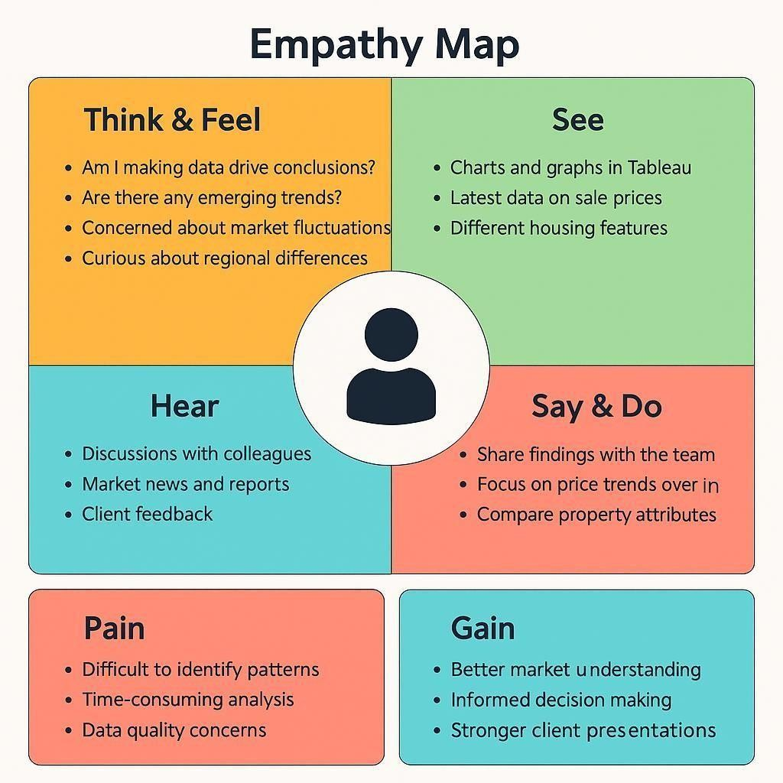
2.3 Brain Storming
Step 1: Team Gathering, Collaboration and Problem Statement
Our team collaborated to identify pressing challenges in the real estate market, particularly in understanding how various property features influence housing sale prices. After exploring themes like housing affordability, real estate investment planning, urban development, and smart property

insights, we narrowed down our focus to uncover actionable insights hidden in housing data. The objective was to visually explore trends using Tableau that would help buyers, sellers, investors, and policy makers understand patterns of sale prices based on features like area, bedrooms, renovation status, condition, location (zipcode groups), and more.
Problem Statement:

4 | Compare prices for renovated vs. non-renovated homes | Renovation Analysis
5 | Group insights by Zipcode Clusters | Geographical Comparison
6 | Analyze house condition vs. price using dummy variables | Quality-Based Pricing
7 | Add calculated field: TotalAreaSqft | Data Preparation
8 | Create SalePriceBin with 100k intervals | Binning / Categorization
9 | Use Tableau dashboard to combine insights | Dashboard Design

10 | Build a Story in Tableau for narrative | Storytelling & Reporting
How can housing sale price trends and property characteristics be visualized and analyzed using Tableau to identify patterns, improve buyer/seller decision-making, and uncover insights that support strategic real estate planning?
Team Members:
- Team Leader: Vadla Venu priya
- Team Member: Sadum Thanuja
- Team Member: Mothukuri Venkata Lakshmi Eshitha
- Team Member: R Jahnavi
- Team Member: Chennaboina Sai Surendra Yadav

Step 2: Brainstorming, Idea Listing and Grouping

S.No Idea Description | Category
1 Visualize average sale price by SalePriceBin | Pricing Insights
2 Analyze impact of number of bedrooms on sale price | Property Features
3 Explore relationship between Total Area and Price (scatter plot) Size-Based Pricing S.No Idea Description Category
- Embed Dashboard in Web Application using Flask Deployment & Integration
- Add filters for Bedrooms, Condition, Renovation in Dashboard Interactive Exploration

Step 3: Idea Prioritization Table

S.No Idea Description Impact Feasibility Priority
- Visualize average sale price by SalePriceBin High Easy High
- Analyze impact of number of bedrooms on sale price High Easy High
- Explore TotalArea vs Price (scatter plot) High Easy High
- Compare prices for renovated vs. non-renovated homes High Medium High
- Group insights by Zipcode Clusters Medium Medium Medium
- Analyze house condition vs. price High Medium High
- Add calculated field: TotalAreaSqft Medium Easy High

- Create SalePriceBin with 100k intervals Medium Easy High
- Use Tableau dashboard to combine insights High Easy High
- Build a Story in Tableau High Medium High
- Embed Dashboard in Web Application High Hard Medium
- Add filters for Bedrooms, Condition, Renovation Medium Easy Medium

Requirement analysis

Customer Journey map

Customer Journey Map: Housing Market Trends Dashboard

Stage | Touchpoints | Pain Points &  Emotions | Opportunities User Goals
Awareness | - Sees  dashboard via social media, newsletter, Tableau Public  - Reads  title/summary | Unclear if Curious, dashboard is Interested relevant | Attract Use benefit-driven interest and titles, visual  clarify  thumbnails purpose
Actions & Experience

- Clicks dashboard link  Engaged,  Consideration - Reads  Cautious introduction, explores layout  - Uses filters for location, price, features  Excited,  - Views charts Inquisitive (bar, scatter, pie,  etc)  - Exports visuals  - Shares dashboard Satisfied,  - Bookmarks or Confident downloads  insights  - Subscribes for updates Loyal,  - Revisits for new Empowered  data  - Leaves feedback | Understand  Overwhelmed by Add guided  the dashboard  layout, unsure walkthrough,  and its where  to start simplify navigation  features

Add example Discover
Filters not intuitive,
Exploration charts slow to load queries,
improve valuable speed insights

7

Decision
Limited export | Enable easy | Preserve and
options or unclear findings formats | download/share, offer export guides | share

No update
Enable email
notifications, Stay informed
Retention updates, actively
feedback and engaged
respond to feedback
unacknowledged

Solution Requirement
Functional Requirements (FRs) FR
No. | Functional Requirement (Epic) Sub Requirement (Story / Sub-Task)
FR-1 | Data Import | - Import data from CSV  - Enable live database integration (MySQL)
FR-2 | Data Cleaning & Transformation | - Handle missing values  - Add calculated fields like Year, Lockdown
FR-3 | Data Visualization | - Create Tableau worksheets - Build multiple dashboards  - Enable filtering by region, year
FR-4 | User Interaction | - View comparative bar charts
 |  | - Analyze pre/post-lockdown trends
 |  | - Role-based views for Analyst, Policy Maker,
FR-5 | User Access | Developer
 |  | - Download/export options
FR-6 | Feedback Loop | - Allow stakeholder feedback and change requests
- Implement revision cycles

Non-Functional Requirements (NFRs) NFR Non-Functional
No. Requirement | Description
NFR-1 Usability | Dashboard must be intuitive with clear filters, legends, and guided walkthroughs
NFR-2 Security | Implement role-based access and secure backend/database connectivity
NFR-3 Reliability | System must handle unexpected data formats and maintain high accuracy
NFR-4 Performance | Ensure fast loading and responsive interaction across all dashboard elements
NFR-5 Availability | Dashboard should be accessible across browsers/devices with minimal downtime
NFR-6 Scalability | Should scale for large datasets and support additional

features/modules

Data Flow Diagram

A Data Flow Diagram (DFD) is a traditional visual representation of the information flows within a system. A neat and clear DFD can depict the right amount of the system requirement graphically. It shows how data enters and leaves the system, what changes the information, and where data is stored.
- Data collected from POSOCO in CSV format.
- Cleaned and transformed, with calculated fields like Year and Lockdown.
- Visualizations built in Tableau using multiple worksheets.
- Users review the dashboard and may request changes.
- Final version archived after approval.

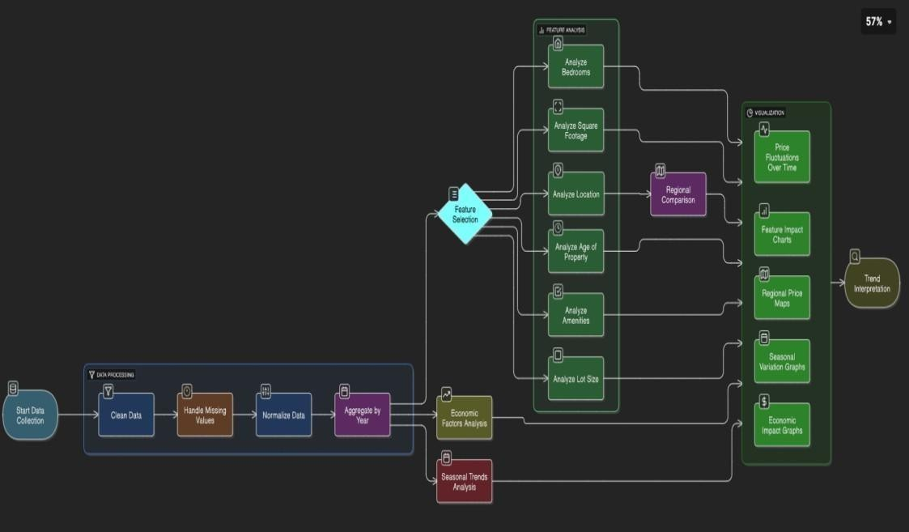
User Stories Table:

Functional User
Acceptance
User Type Requirement Story User Story / Task Priority Release Criteria
(Epic) Number
 | As a user, I want to I can filter and
View
Analyst /  Electricity USN-1  Policymaker  Trends | view electricity view charts for Sprint-  High  usage trends by specific regions 1 region and year. and years.  As a user, I want to I can view bar

Analyst Compare States USN-2 | compare top and charts with top N Sprint-  Medium  bottom electricity- and bottom N 1 consuming states. states.
Forecast  Policy Maker USN-3 Planning | I can view As a user, I want to monthly and  Sprint-  analyze seasonal quarterly High  2  variations in usage. consumption  trends.  As a user, I want to A before-after
Energy View Impact of  USN-4  Consultant Lockdown | compare electricity lockdown chart is Sprint-  High usage before and available for 2 after lockdown. selection.

As a user, I want Data refreshes

Developer Connect Data USN-5

the dashboard to be automatically Sprint-
Medium

As a user, I want to
I can download

Developer Export Insights USN-6 connected to a live from MySQL to 2
database. Tableau.
export dashboard Sprint-
dashboards as Low
views for 3
images or PDFs.
presentations.

  - Technology Stack

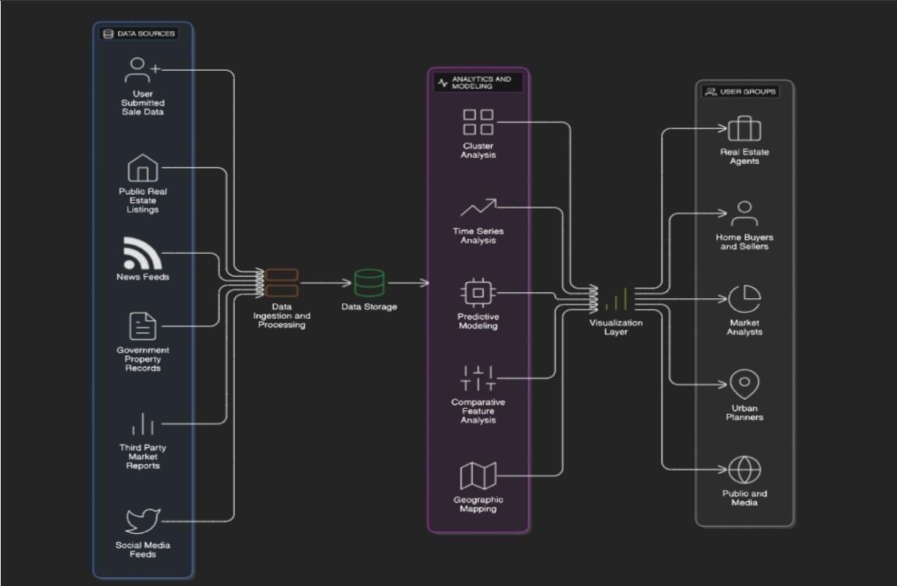

Project design

Problem Solution Fit

The Problem-Solution Fit simply means that you have found a problem with your customer and that the solution you have realized for it actually solves the customer’s problem. It helps entrepreneurs, marketers and corporate innovators identify behavioral patterns and recognize what would work and why.
Purpose:
    - Solve complex problems in a way that fits the state of your customers.
    - Succeed faster and increase your solution adoption by tapping into existing mediums and channels of behavior.
    - Sharpen your communication and marketing strategy with the right triggers and messaging.
    - Increase touch-points with your company by finding the right problem-behavior fit and building trust by solving frequent annoyances, or urgent or costly problems.
    - Understand the existing situation in order to improve it for your target group.
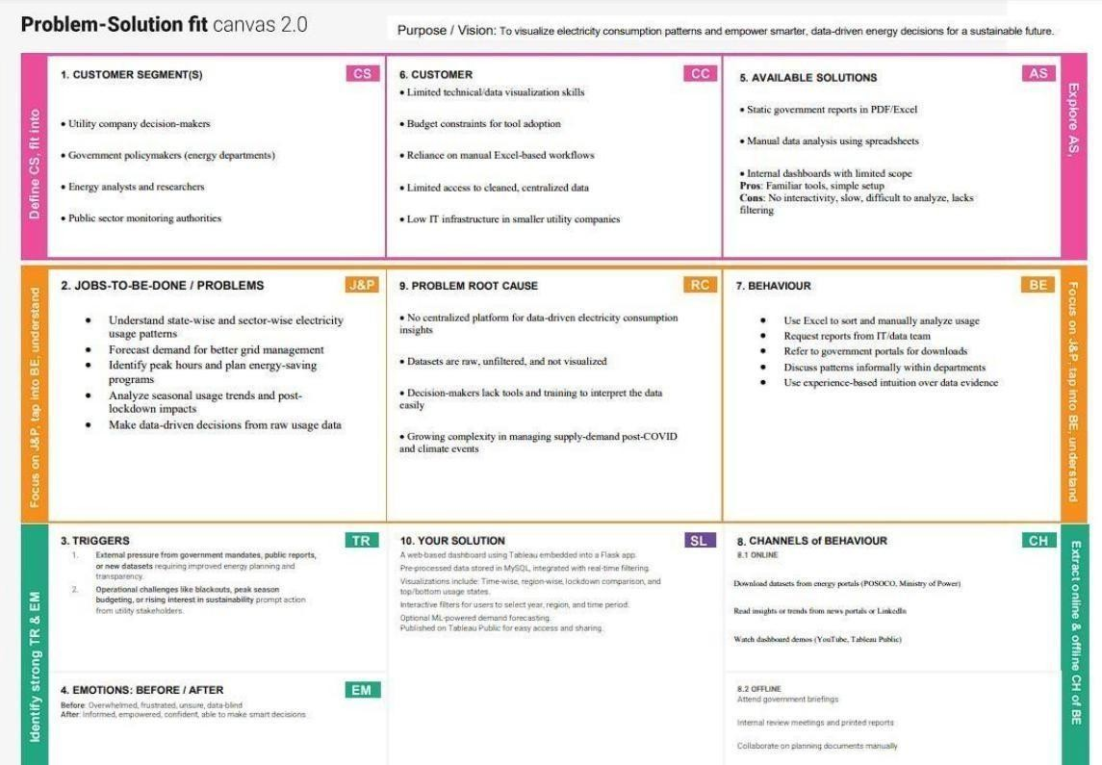

Proposed Solution

Proposed Solution Template

S.No. Parameter |  | Description  The real estate market involves vast and complex datasets on housing
1 | Problem | features and sale prices. These datasets are often underutilized due to lack
 | Statement | of effective visualization, making it difficult for buyers, sellers, and
 |  | analysts to draw insights or forecast trends.
 |  | Our solution transforms static housing datasets into interactive, insightful
2 | Idea / Solution Description | visualizations using Tableau. The project involves cleaning and transforming the data, creating calculated fields and KPIs, and developing  a dashboard that highlights key trends, comparisons, and location-based
 |  | analyses. The solution is deployed via a Flask web app.
 |  | This project leverages Tableau’s powerful visual capabilities to go beyond
3 | Novelty / Uniqueness | basic data analytics. By combining calculated fields, condition segmentation, and geographic mapping, the dashboard offers a dynamic  exploration of how features like bedrooms, area, renovation, and location
 |  | influence housing prices.
4 | Social Impact / Customer Satisfaction | This solution enables real estate buyers, sellers, agents, and market researchers to make informed decisions. It improves housing transparency, supports better urban planning, and enhances user engagement with clear  visuals and actionable insights.
 |  | This dashboard can be scaled and offered as a subscription-based SaaS tool
5 | Business Model to real estate companies, market research firms, or housing consultancies.  (Revenue  Advanced forecasting modules, API integrations, and custom dashboards  Model)
can be monetized as premium features.
The system is designed to be scalable and adaptable. It can incorporate new
Scalability of the datasets (like rental trends or economic indicators), extend to new regions
6
Solution or cities, and integrate with ML models for price predictions, thereby offering long- term growth potential.

Solution Architecture

Solution architecture is a complex process – with many sub-processes – that bridges the gap between business problems and technology solutions. Its goals are to:
- The architecture separates data preprocessing, storage, visualization, and UI layers—making it easy to maintain, scale, and enhance.

- Cleaned data from MySQL is visualized using Tableau dashboards, offering region-wise, year- wise, and seasonal insights with filtering capabilities.
- Dashboards are embedded into a Flask-based web interface, allowing end users to interact with visual data through a user-friendly portal.
- The solution supports future extensions like forecasting models and can be deployed locally or on cloud platforms like Heroku or AWS.
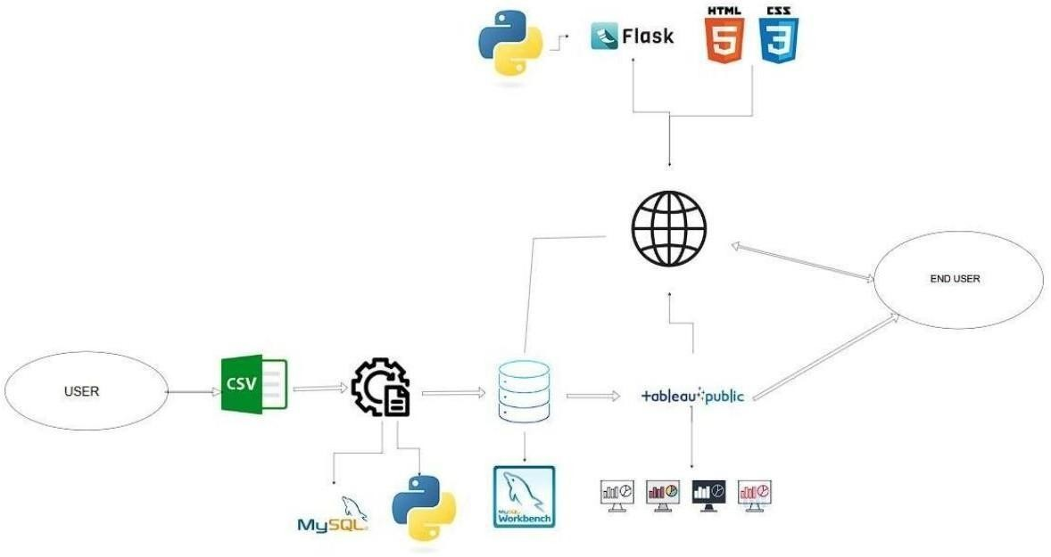

Project planning & scheduling

5.1 Project Planning

User
Sprint | Epic | Story  No. | User Story / Task | Points Priority |  | Assigned To
Sprint-  1 | Data Setup | USN-1 | As a user, I can upload housing data  CSV format | 3 in | High | Vadla Venu Priya
Sprint-  1 | Data Cleaning | USN-2 | As a developer, I can clean and  preprocess housing data in Tableau | 4 | High | Sadum Thanuja
Sprint-  1 | Field Creation | USN-3 | As a user, I can create calculated  2 fields like TotalAreaSqft |  | Medium Mothukuri Venkata Lakshmi Eshitha

Sprint-  Price Binning  1 | USN-4 | As a user, I can create SalePriceBin  2 for grouping houses | Medium R jahnavi
Sprint- Data  2 Visualization | USN-5 | As a user, I can create sheets with  5 charts: price vs features | High | Chennaboina Sai Surendra Yadav
Sprint- Dashboard  2 Creation | USN-6 | As a user, I can build an interactive  3  Tableau Dashboard with filters | High | Sadum Thanuja
Sprint- Dashboard  2 Styling | USN-7 | As a user, I can style the dashboard  2 for  better readability and navigation | Medium | Vadla Venu Priya
Sprint-  Storytelling  3 | USN-8 | As a user, I can create a Tableau  2  Story showing insights step by step | Medium | R Jahnavi
Sprint-  Flask Integration USN-9 3 |  | As a developer, I can embed  Tableau dashboard into a Flask web 4 app | High | Sadun Thanuja
3 Embed Testing USN-10 |  | As a user, I can test and review the print- 2  embedded dashboard UI | Medium | Mothukuri Venkata Lakshmi Eshitha
Sprint-  Documentation USN-11  4 |  | As a team, we can prepare final  3  project documentation | High | Chennaboina Sai Surendra Yadav
Sprint- Demo  USN-12  4 Preparation |  | As a team, we can prepare and  2  rehearse a full demo walkthrough | Medium | Vadla Venu Priya
Sprint- Bug Fixing /  USN-13  4 Final QA |  | As a team, we can test the full  2  system and fix visual/logic bugs | Medium | R Jahnavi

Project Tracker, Velocity & Burndown Chart
Sprin Total Story Poin DuratioStart Date End Date Points CompleteRelease Da

Sprint 11 | 4 Days 06 Feb 2026 09 Feb 2026 11 | 09 February 2026
Sprint 10 | 4 Days 10 Feb 2026 14 Feb 2026 10 | 14 February 2026
Sprint 7 | 4 Days 15 Feb 2026 18 Feb 2026 7 | 18 February 2026
Sprint 7 | 4 Days 19 Feb 2026 22 Feb 2026 7 | 22 February 2026

Velocity Calculation
Total Points Completed: 11 + 10 + 7 + 7 = 35
Total Duration: 4 + 4 + 4 + 4 = 16 days

Average Velocity = Total Points Completed / Total Days = 35 / 16 = 2.19 points/day

Burndown Chart Insight
- Initial Total Story Points: 35
- Sprint-wise burn (Remaining Points): o After Sprint-1: 24 o
After Sprint-2: 14 o After Sprint-3: 7 o After Sprint-4:
0
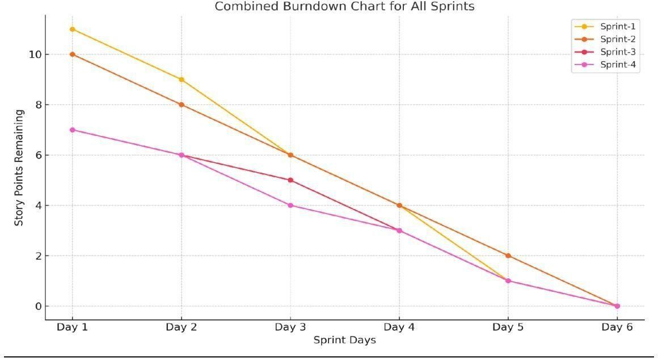

Functional and performance testing
6.1 Performance Testing

S.No | Parameter | Screenshot / Values

1. | Data Rendered | The dataset used contains housing sales data with fields such as Sale  Price, Number of Bedrooms, Bathrooms, Flat Area, Lot Area,  Basement Area, House Age, Condition, Renovation Status, Zipcode Group, and others. The data was provided in .csv format and include derived and transformed columns suitable for advanced analytics and visualizations in Tableau.
2. | Data Preprocessin | Before importing the data into Tableau, preprocessing was done usin Python (Pandas). The following steps were performed:  - Removed null or missing values.  - Renamed columns for clarity (e.g., “No of Bedrooms” → “Bedrooms”).  - Created calculated fields like “TotalAreaSqft” (sum of flat, lo  and basement areas).  - Generated dummy variables for house conditions and renovation status.  - Transformed categorical fields to improve Tableau usability. The final cleaned dataset was stored and imported into Tableau for visualization.

3. | Utilization of Filters | Multiple filters were implemented in Tableau to improve interactivity and user exploration. These include:  - Number of Bedrooms  - Number of Bathrooms  - House Condition  - Renovation Status (Yes/No)  - Zipcode Group  - Sale Price Bins  These filters allow users to drill down and compare trends across different property types and regions.

4 | Calculated Fields Used | Several calculated fields were created in Tableau to enhance analysis and interactivity:  - TotalAreaSqft → [FlatAreaSqft] + [LotAreaSqft] + [BasementAreaSqft]  - SalePriceBin → Binning Sale Price into ₹100,000 intervals  - Condition_Excellent, Condition_Good, etc. → Dummy fields (0/1  - Ever_Renovated_Yes → Dummy field to identify renovated home  - AvgPrice → AVG([SalePrice]) for grouped insights  - HouseAge → Difference between year built and sale date if available  (or derived field if pre-calculated)  These fields enable comparisons across pricing, condition, and space utilization.

5 | Dashboard | 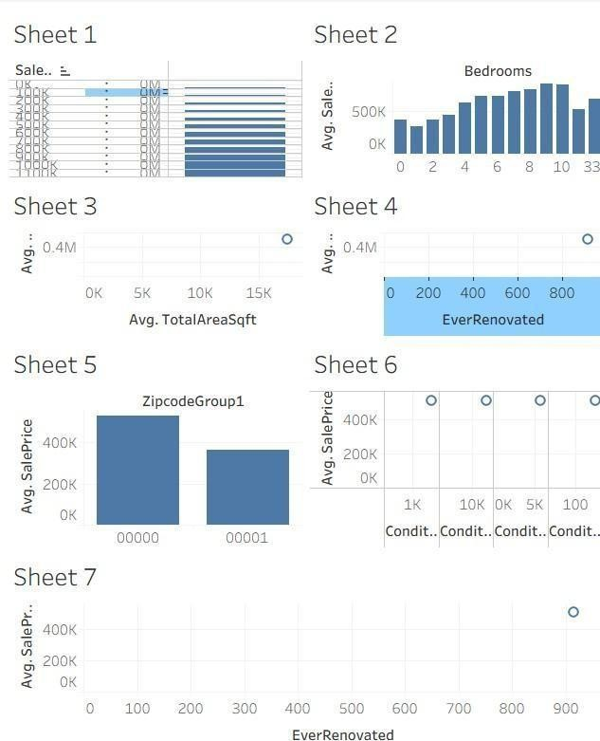

6 | Story Design | 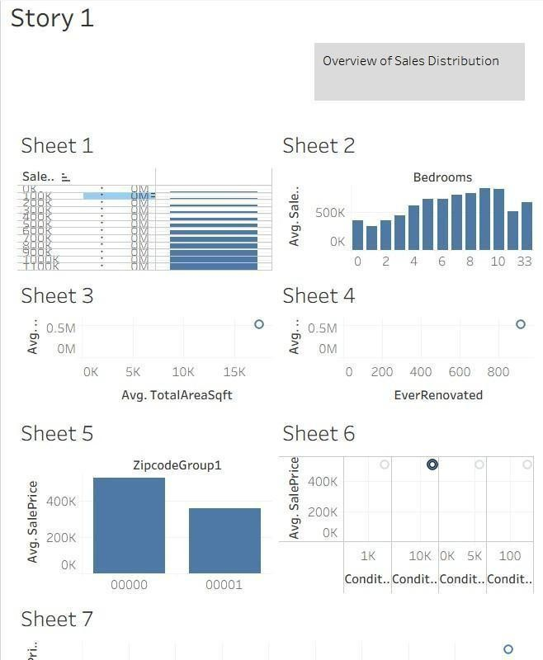

Results

7.1 Output Screenshots

Output of Sheet 1

Output of
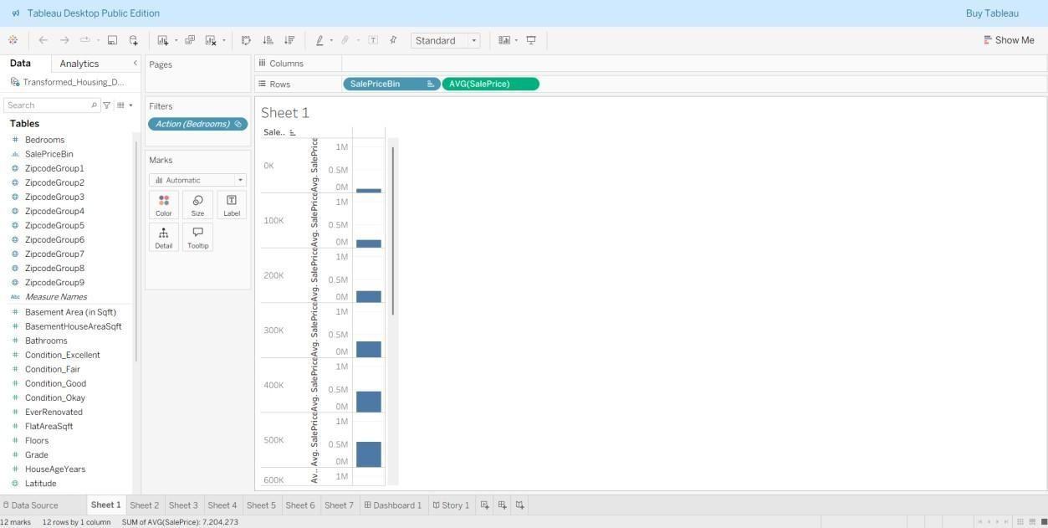

Output of Sheet 2
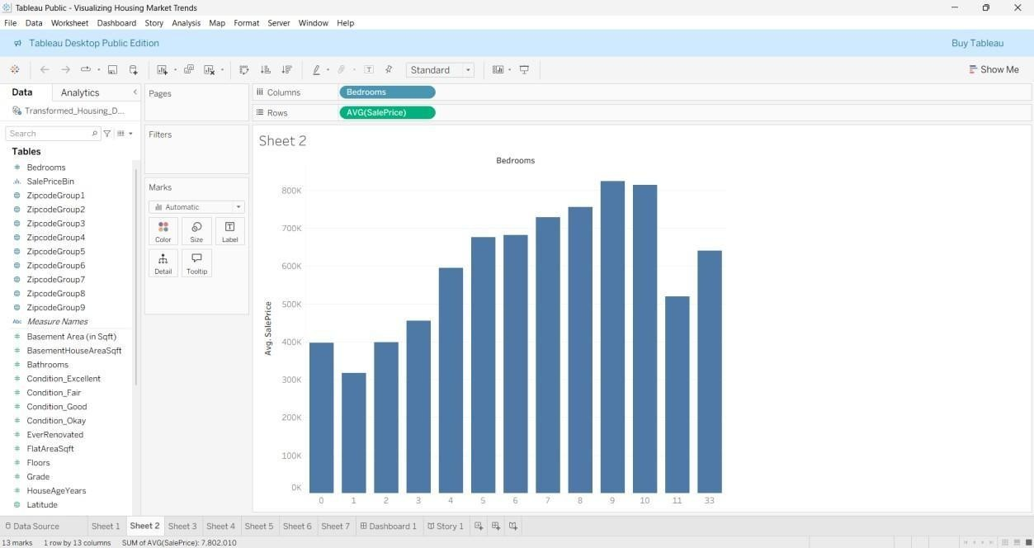
Sheet 3

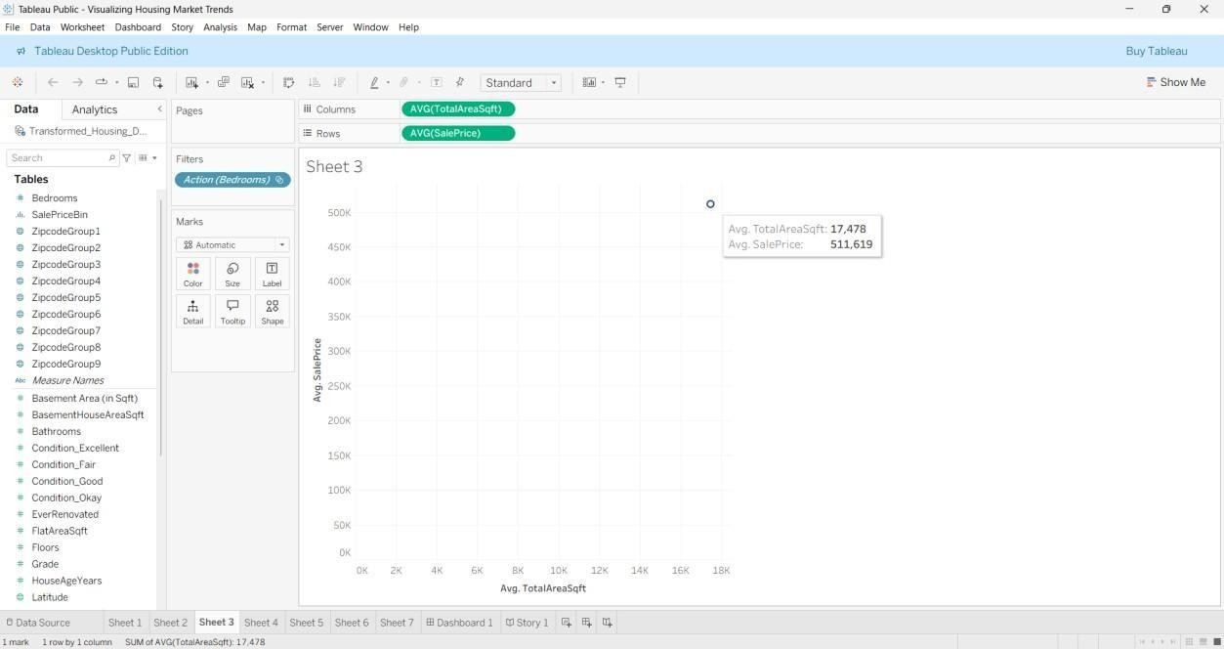

Output of Sheet 4
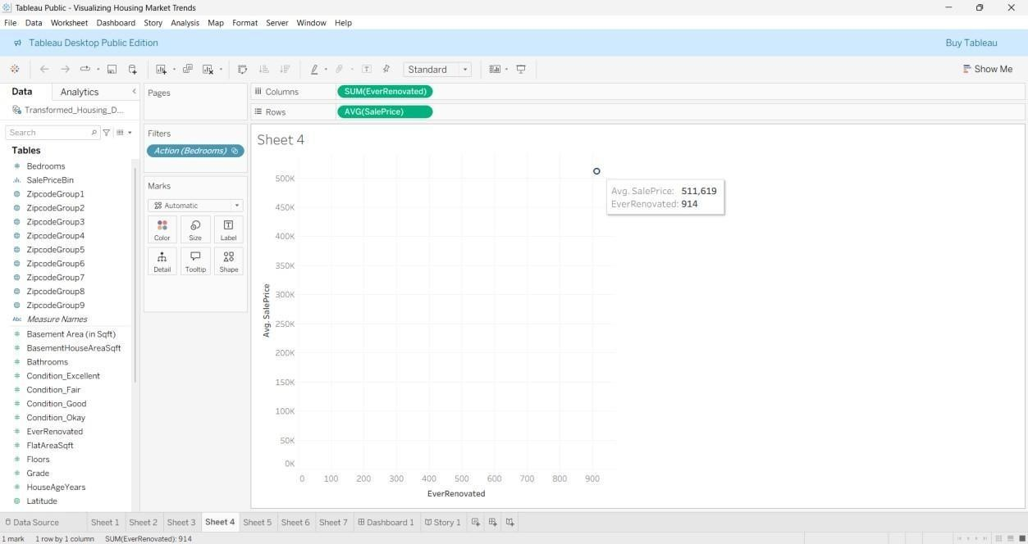

Output of

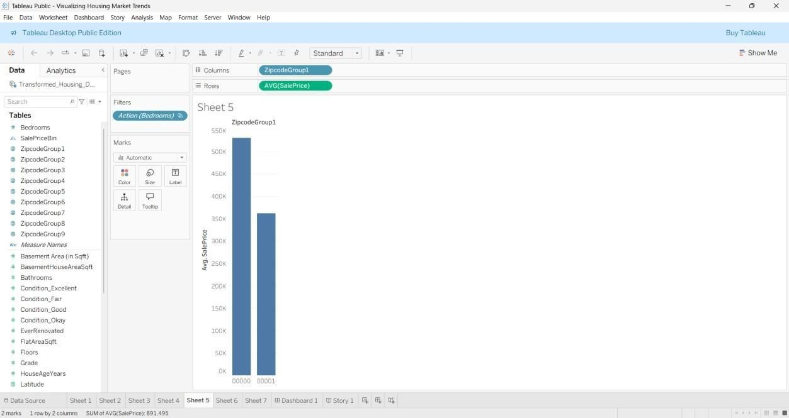
Sheet 5

Output of Sheet 6

Output of
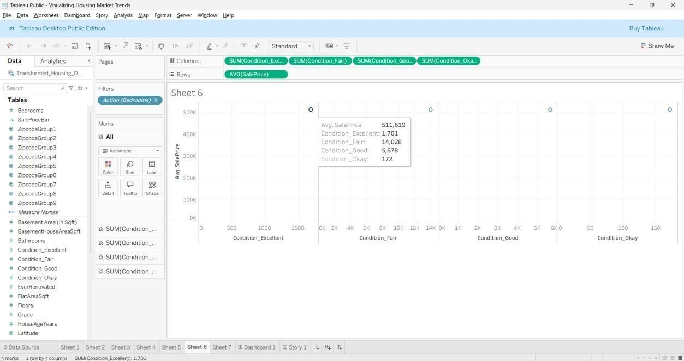
Sheet 7
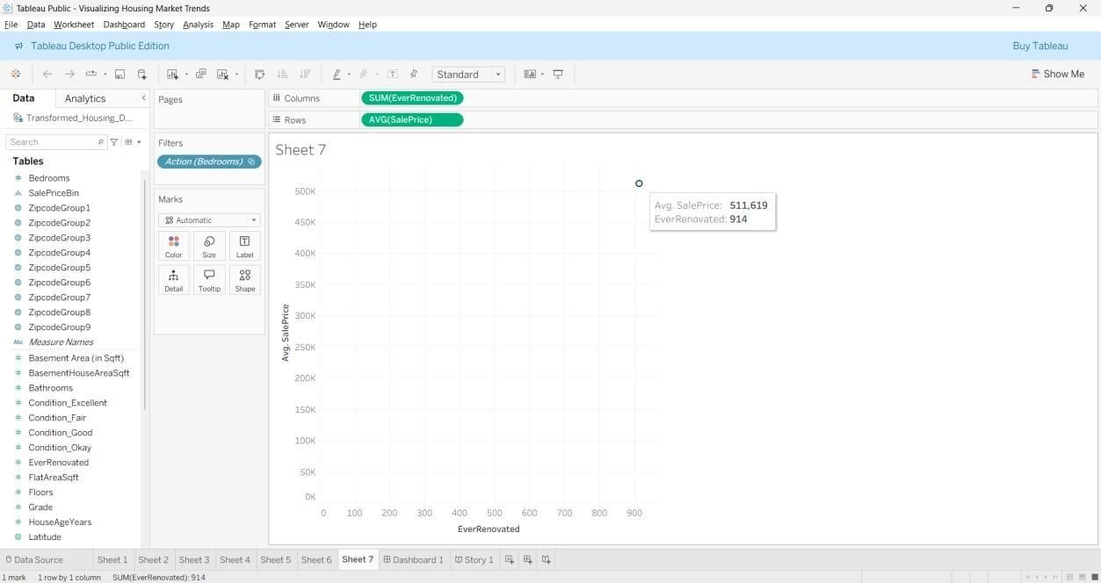

Output of

Output of Dashboard
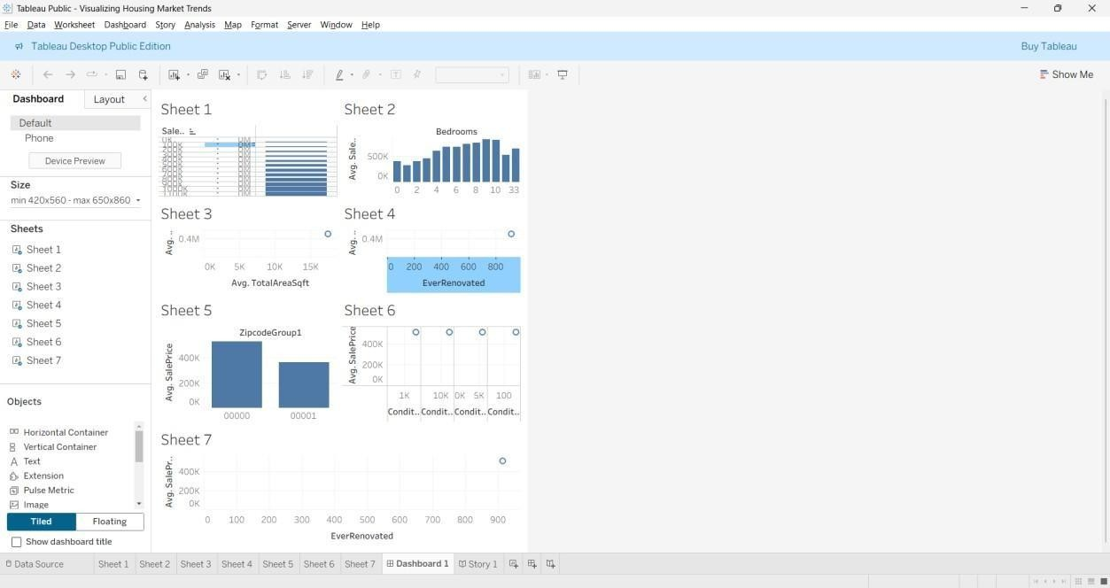
Story

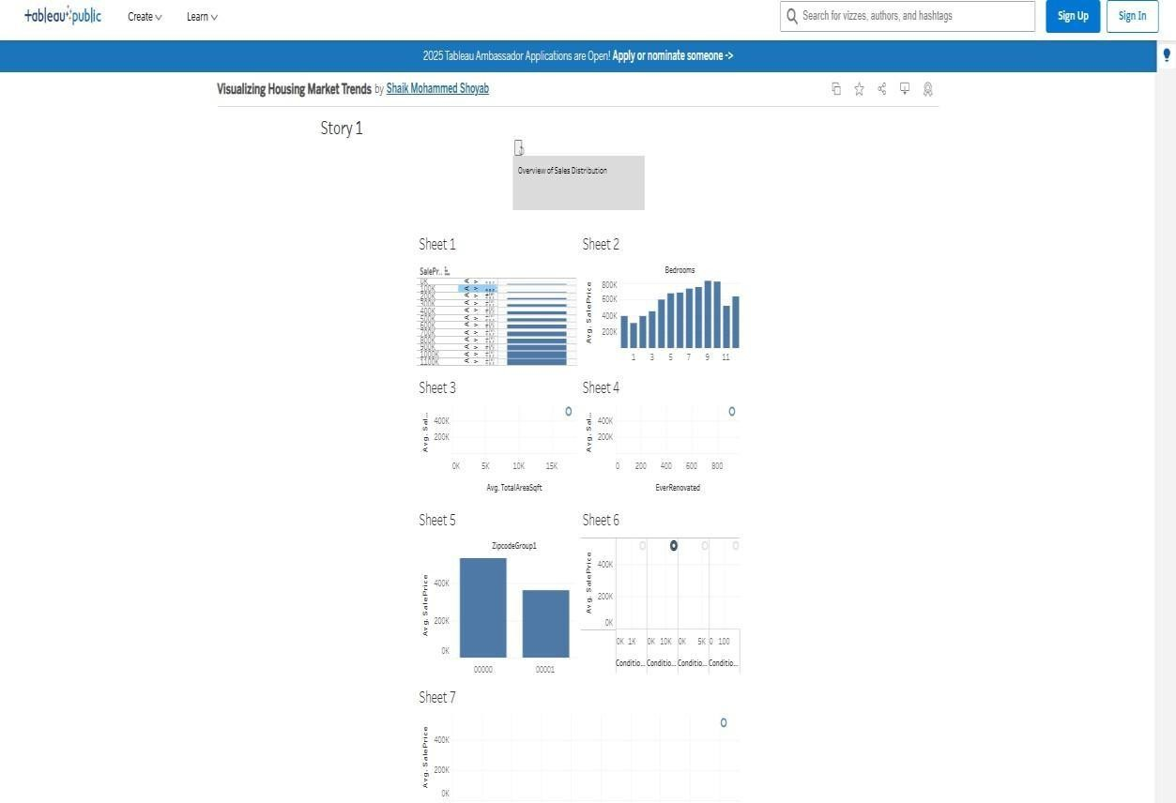

Output of
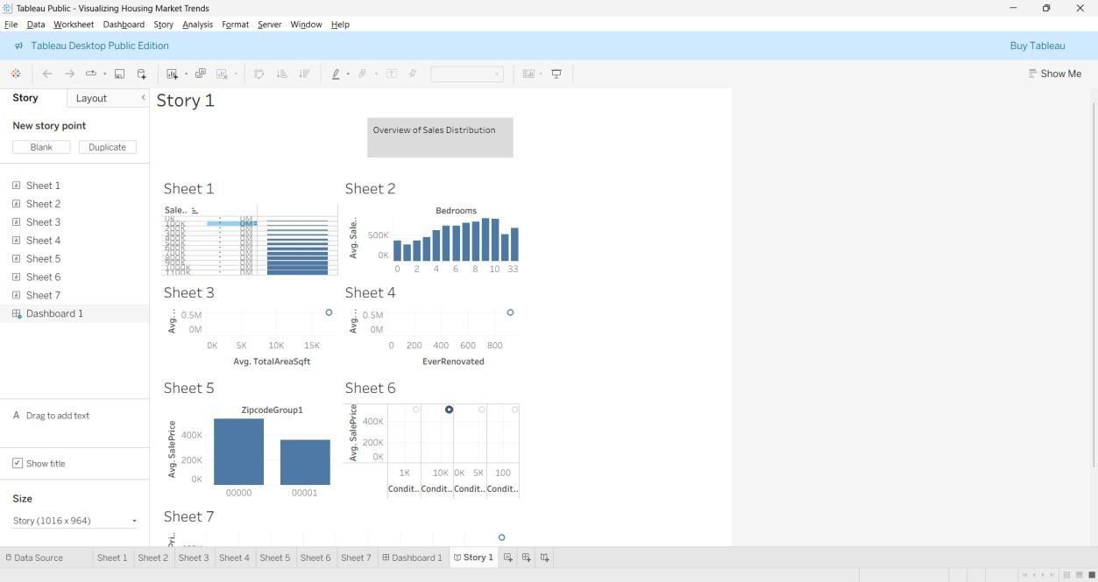

Tableau public link

https://public.tableau.com/views/VisualizingHousingMarketTrends_17508278225630/ St ory1?:language=en- US&publish=yes&:sid=&:redirect=auth&:display_count=n&:origin=viz_share_link

Output
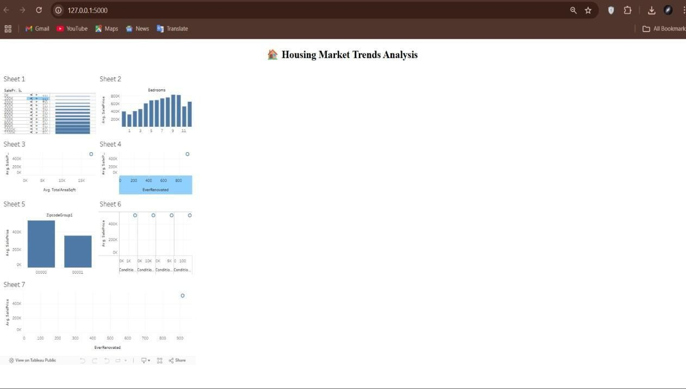

Advantages & disadvantages

Advantages:
- Interactive Analysis:
The Tableau dashboard allows users to explore data with filters (e.g., bedrooms, renovation status, price bins), enhancing understanding through dynamic interactions.
- Informed Decision-Making:
Buyers, sellers, agents, and investors can make data-driven decisions by identifying which features (e.g., area, renovations, number of floors) impact property value.
- Data Storytelling:
The Tableau Story feature presents insights in a sequential, digestible narrative—great for business reports or stakeholder presentations.
- Geographic Visualization:
Zipcode grouping allows regional comparison of price trends and property types, revealing market opportunities and local disparities.
- Calculated Metrics & KPIs:
Metrics like Average Sale Price and Total Area improve business clarity and enable fast comparisons across categories.
- Web Accessibility:
Embedding the dashboard into a Flask web app increases accessibility—users can view it from any browser without needing Tableau Desktop.
- Modular & Scalable Design:
The project structure supports additional data (e.g., rental prices, future years), making it expandable to other regions or market conditions.
- Minimal Coding Required:
Most of the visualizations are created using Tableau’s drag-and-drop interface—making it ideal for analysts without deep programming expertise.

Disadvantages:
- Static Dataset Limitation:
The analysis depends on a preloaded CSV file; it doesn’t support real-time updates unless integrated with live databases or APIs.
- Tool Dependency:

The system relies on Tableau Public, which has limitations like no row-level security and requires dashboards to be public. 3. Learning Curve for Tableau:
While Tableau is user-friendly, new users may need time to understand calculated fields, filters, and advanced charting options.
- Limited Predictive Power:
This is a descriptive and visual analytics project—it does not use machine learning or predictive modeling to forecast housing prices.
- Browser Compatibility:
Older browsers or low-resolution screens may not render complex dashboards optimally, especially if not designed responsively.
- Manual Data Preprocessing:
Initial data cleaning, renaming, and transformation were done manually using Python or within Tableau, which might be error-prone at scale.

Conclusion:
The project "Visualizing Housing Market Trends: An Analysis of Sale Prices and Features using Tableau" successfully demonstrates how complex real estate data can be transformed into meaningful, interactive visual insights. By leveraging Tableau’s powerful visualization capabilities, we have made it easier for buyers, sellers, investors, and analysts to understand the key factors influencing house prices. Our dashboard enables quick comparisons based on features like number of bedrooms, renovations, house age, and geographic location. The integration with Flask provides a seamless web interface, enhancing accessibility and usability. Overall, this project bridges the gap between raw housing data and strategic real estate decision-making, allowing users to gain actionable insights with minimal technical expertise.

Future scope:
- Live Data Integration:
Future versions can integrate live property listings or transaction data via APIs or real-time databases to provide up-to-date market insights.
- Machine Learning Forecasting:
Incorporating regression models or time-series forecasting can help predict future housing prices based on historical trends and features.
- Rental Market Visualization:
Extend the dashboard to include rental data analysis, enabling a broader comparison between buying vs. renting decisions.
- Mobile Optimization:
Responsive design enhancements can be implemented to ensure the dashboard performs well across tablets and smartphones. 5. Advanced User Access Control:
By using Tableau Server or Tableau Online, dashboards can be secured with role-based access for different stakeholders.
- Location Intelligence Enhancements:
Integration of geospatial data, satellite maps, or demographic overlays can improve location- based insights (e.g., school zones, crime rates).
- Recommendation Engine:
Develop a recommendation system to suggest optimal property types using user-input filters.

Appendix

Source Code:
index.html
<!-- templates/index.html -->
<!DOCTYPE html>
<html lang="en">
<head>
<meta charset="UTF-8">
<title>Housing Market Dashboard</title>
</head>
<body>
<h1 style="text-align: center;">_^¡ · Housing Market Trends Analysis</h1>
<div class='tableauPlaceholder' id='viz1750827980701' style='position: relative'>
<noscript>
<a href='#'>
<img alt='Dashboard 1 ' src='https://public.tableau.com/static/images/Vi/VisualizingHousingMarketTrends_175082 78 225630/Dashboard1/1_rss.png' style='border: none' /> </a>
</noscript>
<object class='tableauViz' style='display:none;'>
<param name='host_url' value='https%3A%2F%2Fpublic.tableau.com%2F' />
<param name='embed_code_version' value='3' />
<param name='site_root' value='' />
<param name='name' value='VisualizingHousingMarketTrends_17508278225630&#47;Dashboard1' />
<param name='tabs' value='no' />
<param name='toolbar' value='yes' />
<param name='static_image' value='https://public.tableau.com/static/images/Vi/VisualizingHousingMarketTrends_17508 2 78225630/Dashboard1/1.png' />
<param name='animate_transition' value='yes' />
<param name='display_static_image' value='yes' />
<param name='display_spinner' value='yes' />

<param name='display_overlay' value='yes' />
<param name='display_count' value='yes' />
<param name='language' value='en-US' />
<param name='filter' value='publish=yes' />
</object>
</div>
<script type='text/javascript'> var divElement = document.getElementById('viz1750827980701'); var vizElement = divElement.getElementsByTagName('object')[0]; if (divElement.offsetWidth > 800) {
vizElement.style.minWidth = '420px'; vizElement.style.maxWidth = '650px'; vizElement.style.width = '100%'; vizElement.style.minHeight = '587px'; vizElement.style.maxHeight = '887px'; vizElement.style.height = (divElement.offsetWidth * 0.75) + 'px';
} else if (divElement.offsetWidth > 500) { vizElement.style.minWidth = '420px'; vizElement.style.maxWidth = '650px'; vizElement.style.width = '100%'; vizElement.style.minHeight = '587px'; vizElement.style.maxHeight = '887px'; vizElement.style.height = (divElement.offsetWidth * 0.75) + 'px';
} else { vizElement.style.width = '100%'; vizElement.style.height = '1527px';
} var scriptElement = document.createElement('script'); scriptElement.src = 'https://public.tableau.com/javascripts/api/viz_v1.js'; vizElement.parentNode.insertBefore(scriptElement, vizElement);
</script>
</body>
</html>
app.py
from flask import Flask, render_template

app = Flask( name )

@app.route('/') def home():
return render_template('index.html')

if name == ' main ': app.run(debug=True)

Project Structure
housing_dashboard/
├── app.py # Flask server that renders the homepage
└── templates/
└── index.html # Web page embedding the Tableau dashboard

Dataset Link
https://docs.google.com/spreadsheets/d/1blBKrwunCQaiccy5sLP6mG4TsanJkO0C/edit?usp
=drive_link&ouid=117818466889783119367&rtpof=true&sd=true

Project Demo Video Link
https://drive.google.com/file/d/11K52njE_QNJyFBY05SuHwp_lasRsPVPv/view?usp=drive_link

GitHub Repository Link

https://github.com/venkatsai110804/Visualizing-Housing-Market-Trends-An-Analysis-of- Sale-Prices-and-Features-using-Tableau

